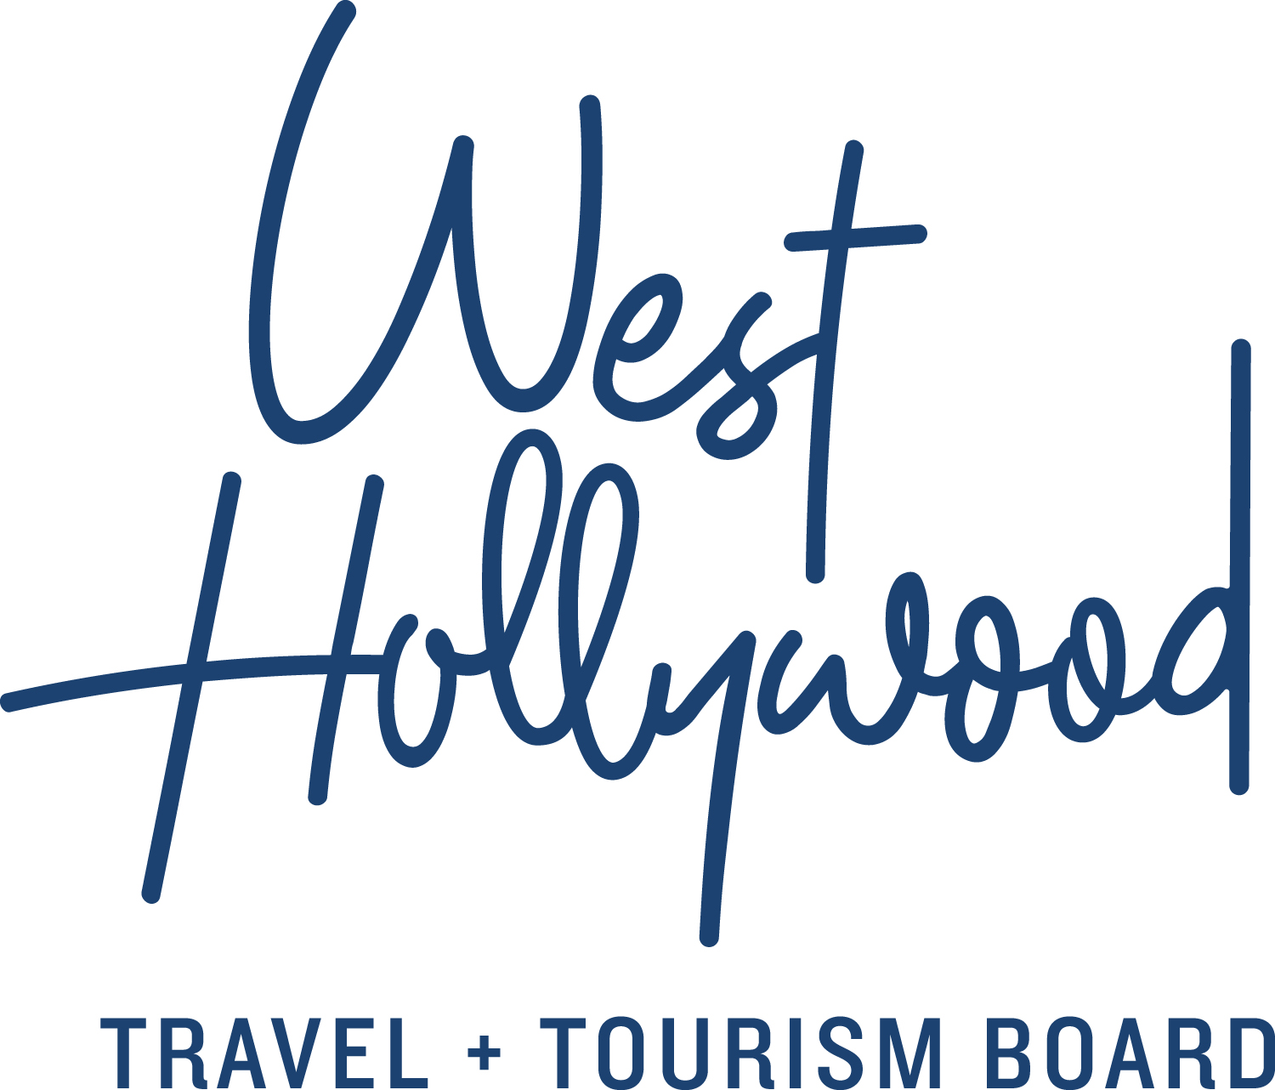

WEST HOLLYWOOD’S LEGENDARY SUNSET STRIP HEATS UP WITH SUMMER ON SUNSET “A TRIBUTE TO THE SUMMER OF LOVE”
JUNE 21–SEPTEMBER 3, 2018

With a $100 credit for a two-night hotel stay and special offers from local businesses,
plus an event series featuring music, dining, and entertainment,
the inaugural Summer on Sunset celebration ushers in a new moment for the Strip

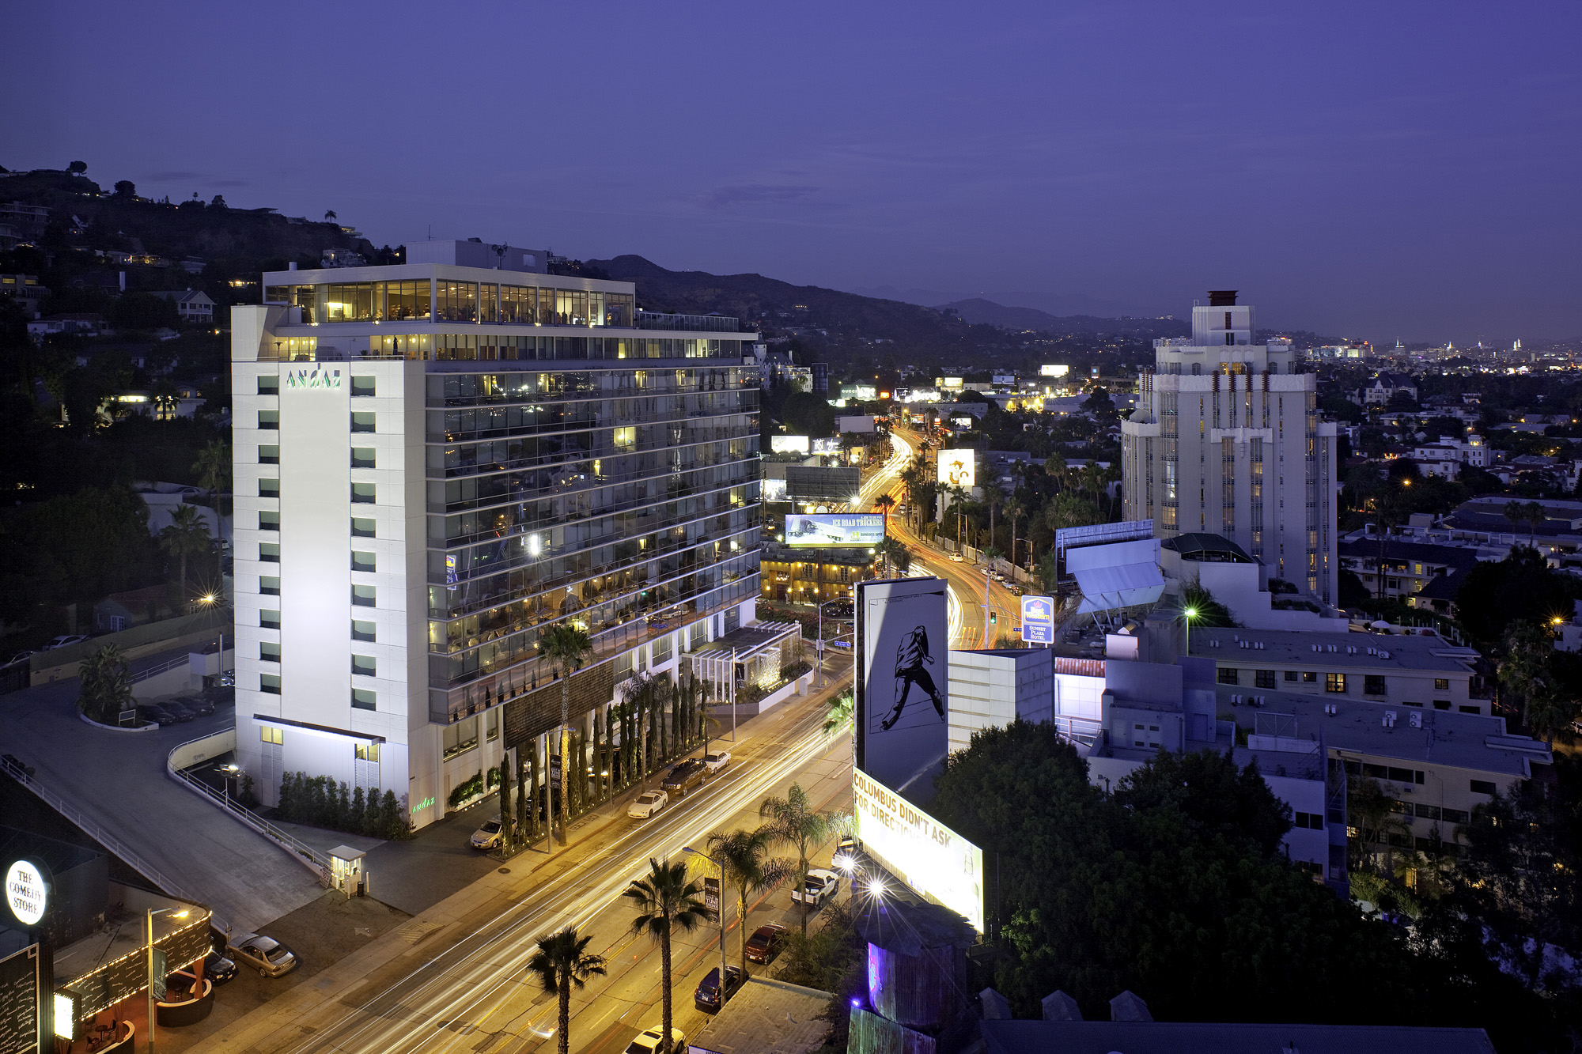
West Hollywood’s legendary Sunset Strip

(WEST HOLLYWOOD, CA; June 5, 2018)—Coinciding with the first official day of summer, the Summer on Sunset celebration—a partnership between West Hollywood Travel + Tourism Board and The City of West Hollywood with local businesses on the Sunset Strip—kicks off on June 21, 2018 with an exciting series of events and special offers available through September 3, 2018. This year’s inaugural theme—“A Tribute to the Summer of Love”—commemorates the nearly 100,000 young activists and dreamers who traveled to San Francisco’s Haight-Ashbury during the Summer of 1967 to join a community of artists, musicians, poets, and radicals for the landmark “Summer of Love.” West Hollywood’s Summer on Sunset series reignites that cultural movement, one that celebrates the influence of pop culture through music, dining, and entertainment on the Strip.

The activists, innovators, creatives, and ground-breakers of today may experience all that the Strip has to offer by booking a hotel reservation via the West Hollywood Travel + Tourism Board’s website (reservations.visitwesthollywood.com) for $100 credit for a two-night stay between June 21 and September 3, 2018 at participating hotels as well as an exclusive Summer on Sunset VIP card valued at $200. Promotional offers include, but are not limited to, half-price signature cocktails at Cabo Cantina and Sunset Trocadero; complimentary small plates at The Jeremy West Hollywood’s Joao Cocktail Bar; complimentary beverages with the purchase of an entrée at The Den on Sunset, BOA, Katana, and ROKU; as well as 20% off the entire bill at restaurants including Pearl’s and Rock & Reilly’s, among others.

“Over fifty years after the ‘Summer of Love,’ we look back at this influential time and are inspired by a socio-cultural movement stemming from a season of romance." says Tom Kiely, President & CEO of West Hollywood Travel + Tourism Board. “West Hollywood has always been a creative and progressive city that embodies the quintessential L.A. lifestyle. As the Sunset Strip continues to blaze its own path as a world-famous cultural landmark, setting trends in music, hotels, dining, and design, we invite those from near and far to fall in love with the Strip’s rebellious, forward-thinking spirit.”

Summer on Sunset celebrates the Strip’s past as a major gathering place for the counterculture movement of the 1960’s when hippies, musicians, and artists flooded the streets of West Hollywood. Additionally, the festival pays homage to the indulgent past of the city’s iconic entertainment venues such as Whisky a Go Go, The Roxy and The Troubadour, which rose to notoriety by hosting acts like Led Zeppelin, The Doors, Elton John, Janis Joplin, Jimi Hendrix, and Jim Morrison.

Summer on Sunset continues to feature similar sounds and unique programming, attracting crowds to legendary music venues and hotels on the Strip:
- The Viper Room | The Sunset Jam brings together the top touring musicians in a completely unrehearsed night of live music, every Monday at 8:30 p.m. The Viper Room will host ‘Jim Morrison Birthday Celebration’ with Peace Frog (The Doors Tribute) on Tuesday, July 3 at 8:30 p.m.
- Whisky a Go Go |An anchor on the Sunset Strip since its opening in 1964, the venue will host up and coming new artists as well rock ‘n’ roll cover bands like the Led Zepagain on Saturday, August 4 at 8 p.m. and L.A. GUNS on Friday, July 13 at 6:00pm
- The Standard | KCRW’s DJ Valida curates two acoustic musical acts to perform unplugged in the Cactus Lounge every Wednesday at 7 p.m. for an intimate evening evoking an impromptu jam in a musician’s living room
- Sunset Marquis | Serving as a home away from home for incredible musicians for more than fifty years, Sunset Marquis continues its tradition, the acoustic music showcase, Live@Sunset Marquis, on select Fridays this summer (June 29, July 13, August 3 & 24)
- Andaz West Hollywood | A legendary rock n’ roll hotel formerly known as the Riot Hyatt, Andaz West Hollywood will host “Sunsets on Sunset” every Thursday from 5 p.m. to 9 p.m. for guests and locals to enjoy music, food, cocktails and games while taking in the 360 degree views from their rooftop pool.
- London West Hollywood at Beverly Hills |The London’s Boxwood on the Roof is celebrating the summer season with live music on Wednesday nights with Jacob Mondry, a Crystal Cocktail menu on Tuesdays, and Ice Cream Sundays to end the week on a sweet note.

While easily accessible via foot—West Hollywood has a Walk Score® of 91—The City of West Hollywood adds a complimentary nighttime shuttle, the Sunset Trip, to transport patrons along the Strip. Shuttles run everyone 15 minutes from 7 p.m. to 3 a.m. along Sunset Boulevard while also connecting to stops on neighboring streets, including Santa Monica Boulevard where guests can transfer to The PickUp shuttle.

About Summer on Sunset
Summer on Sunset is a three-month celebration of music, dining, and entertainment on the legendary Sunset Strip. West Hollywood Travel + Tourism Board in partnership with the City of West Hollywood and local businesses will mark the inaugural festival with the theme “A Tribute to the Summer of Love.” The exciting series of events and special offers will kick off on the first official day of summer, June 21, 2018 through September 3, 2018. For more information, please visit visitwesthollywood.com/summeronsunset.

About West Hollywood Travel + Tourism Board
West Hollywood Travel + Tourism Board is the official marketing organization that invites visitors to West Hollywood, CA, a walkable, 1.9 square mile/4.9 square kilometer city in the heart of Los Angeles. Located at the base of the Hollywood Hills and adjacent to Beverly Hills, West Hollywood is a creative and progressive city that embodies the quintessential L.A. lifestyle. West Hollywood is home to 17 hotels and comprised of three main districts: the world-famous Sunset Strip with unparalleled nightlife, eclectic and LGBTQ-friendly Santa Monica Boulevard, and the Design District known for its sought-after shopping and dining. West Hollywood enjoys a year-round moderate climate and thanks to its prime location and hip atmosphere, the city serves as home and playground to an array of celebrities. Follow us on Facebook & Twitter (@westhollywood) and Instagram (@visitweho) or visit us online at www.visitwesthollywood.com

FOR MORE INFORMATION, PLEASE CONTACT

ANJELICA MAGEE AT WAGSTAFF WORLDWIDE

anjelica@wagstaffworldwide.com

323.871.1151

# # #

