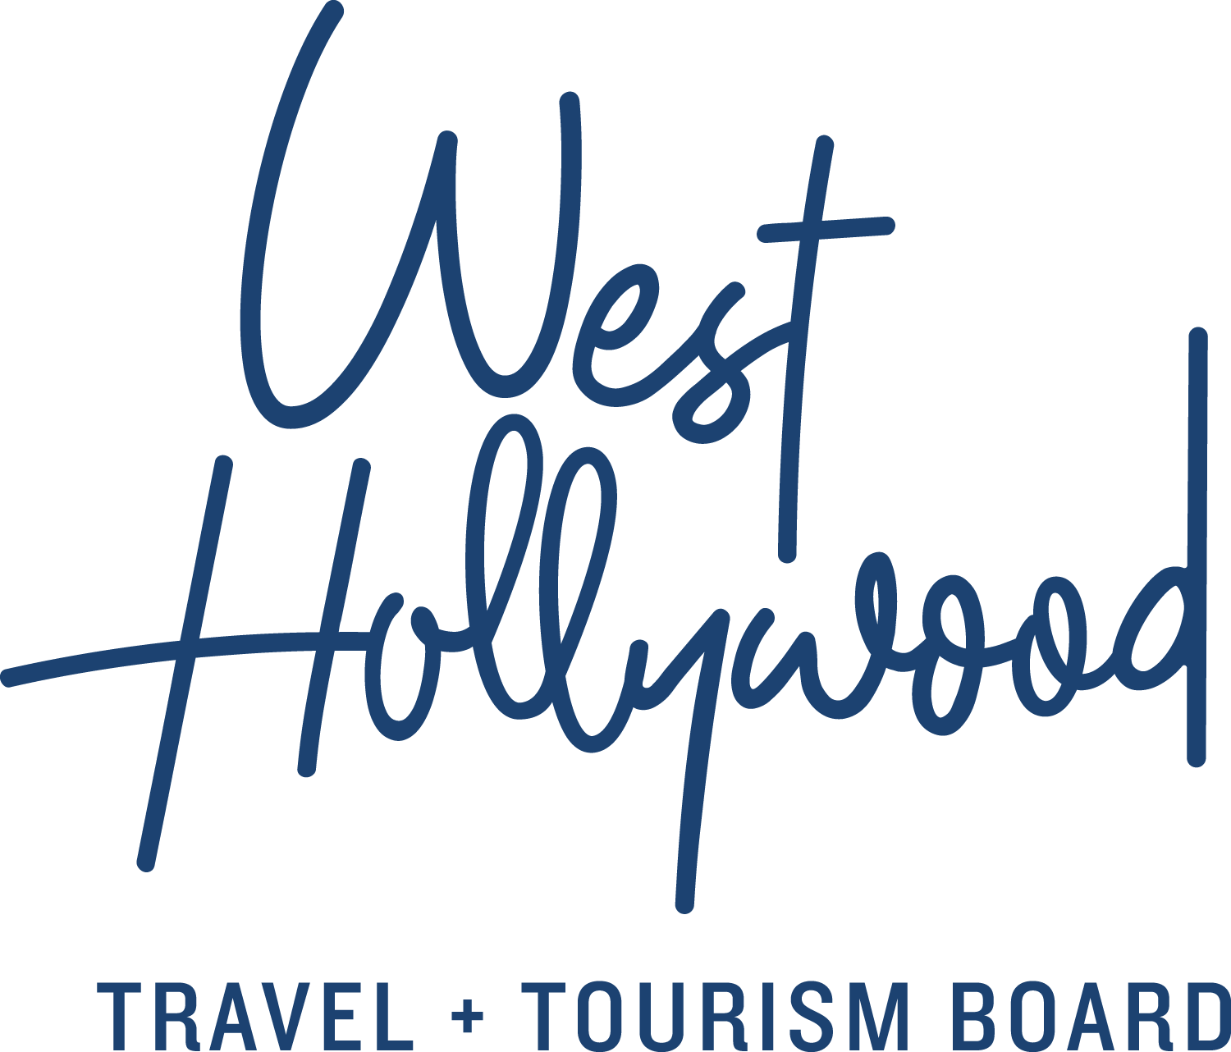

Top Ten Instagrammable Spots in West Hollywood, California

We came, we saw, we snapped, we posted. And with those four little actions, a bigger identity was created (or at least projected). Self-expression rules in West Hollywood, California – with or without the help of a selfie stick.
Some of the places in West Hollywood's Top Ten Instagram spots are recognizable to all, while others deliberately signal to an inside crowd. "Look, I'm here in West Hollywood, IRL." Straight up or filtered through an Instagram trick, life looks better in welcoming West Hollywood.
Here are West Hollywood's top spots for capturing the perfect image, in alphabetical order, because ranking them is too personal. Be sure to use @visitweho to garner maximum audience accolades.
Alfred Coffee (@alfred)
As they say, “But first, coffee” while first-time patrons say, “But first, selfie.” Whether it's the triangular black-and-white tile or the avocado toast, there's a cool-factor here that's on par with its alley location next to Cycle House (yeah, the one where Khloe Kardashian and others work out). Don’t miss Alfred Tea Room in Melrose Place; it’s a millennial pink dream.
Cycle House (@cyclehousela)
Take a spin (class) and then strike a pose in the alley (preferably in a piece of designer athleisure apparel in front of JGoldcrown's love mural) with a sweaty glow that says, “I came, I rode, I clicked, therefore I am.” That and the buff abs are testimony enough to being alive.
E.P. & L.P. (@eplosangeles)
This deservedly acclaimed duo is known for a few things: its “Young and Free” neon sign that screams selfie; its rooftop happy hours and evening noshing beside a pink “Where Love Lives” neon sign; and its cool, self-described modern Asian eating house vibe.
Gracias Madre (@gmweho)
It's always a good day to say Thanks Mom, a place that celebrates organic Mexican food and the people who grow, cook and serve it. You can't capture the spirit of the place in pixels, but you can sure try – with sun glinting off their boozy snow cones or popsicles or with naturally stylized dishes that almost look too good to eat. Please, though, do eat while it's hot.
The Hollywood Sign (@hollywoodsign)
Newsflash (not): The Hollywood Sign is the single most iconic backdrop in the area. And practically no one is “above it” – that is, being photographed here. A lot of images are taken from a fair distance away at the Griffith Observatory. But Bikes and Hikes LA gets you up close and personal while a drone can capture the view for your group. They will even add your image as a cake topper for a special day.
Maxfield (@maxfieldla)
Ohhh, how rich and textured and nuanced the palette of grey concrete on those… cement monkeys. Yup, the courtyard entrance of this avant-garde boutique and one-off gallery across the street is playfully guarded by a duo of primitively styled primates. They are almost as famous as what's inside.
Paul Smith's Pink Wall (#paulsmithpinkwall)
L.A. and West Hollywood are full of brightly colored murals, but there's nothing quite as simple and arresting as the Bazooka bubble gum pink box that wraps this retail location of Paul Smith. It makes Barnett Newman's color fields and Mark Rothko's abstract expressionism look downright dour.
RETNA Mural at Craig’s (@ironeyeretna)
On the wall outside of Craig's, the all-American restaurant favored by celebs in the Design District, this mural gives rise to the existential question: if a backdrop was seen and not ‘grammed, did it ever exist? Street artist RETNA never had to ask that question since he's been creating his distinctive typography on the streets of L.A. since he was a teenager.
The Abbey (@theabbeyweho)
The crown jewel of WeHo's gay clubbing scene is the place to be seen with gorgeous go-go dancers, buff boys and boozy bartenders. Cocktails are as chill as the music is hot. You'll be forgiven if you hand your camera to a friend to take a better-perspective “selfie”.
Skybar at the Mondrian LA (@skybarla)
Day drinking rarely looks as fun as it does at Skybar, where partying poolside also means partying inside the pool. Come dusk, as candles start flickering, catch a flick while lounging poolside. Come evening, catch a poolside band. No matter the time of day, city views are unparalleled from this ivy-covered pavilion.
West Hollywood City Hall Selfie Wall (@wehocity #WeLoveWeHo)
Looking for a selfie passport stamp like the Welcome to Las Vegas sign or the South Rim of the Grand Canyon? West Hollywood has its own version: the City installed a rainbow tile graphic showing WeHo’s tiny size and boundaries. The exterior wall is part of a micro-park project that provides passers-by a place to gather, snap, post, then chill. You're welcome. Go forth, share, like, conquer.
For more information, get a listing of what’s new, and suggestions on where to sleep, eat and drink, go to www.visitwesthollywood.com.

About West Hollywood Travel + Tourism Board
West Hollywood Travel + Tourism Board is the official marketing organization that invites visitors to West Hollywood, California, a walkable, 1.9 square mile/4.9 square kilometer city in the heart of Los Angeles. Located at the base of the Hollywood Hills and adjacent to Beverly Hills, West Hollywood is a creative and progressive city that embodies the quintessential L.A. lifestyle. West Hollywood is home to 17 hotels and comprised of three main districts: the world-famous Sunset Strip with unparalleled nightlife, eclectic and LGBTQ-friendly Santa Monica Boulevard, and the Design District known for its sought-after shopping and dining. West Hollywood enjoys a year-round moderate climate and thanks to its prime location and hip atmosphere, West Hollywood serves as home and playground to many celebrities. Follow us on Facebook & Twitter (@westhollywood) and Instagram (@visitweho). www.visitwesthollywood.com
##
Press Contact:
Anne Van Gorp, media@visitwesthollywood.com

