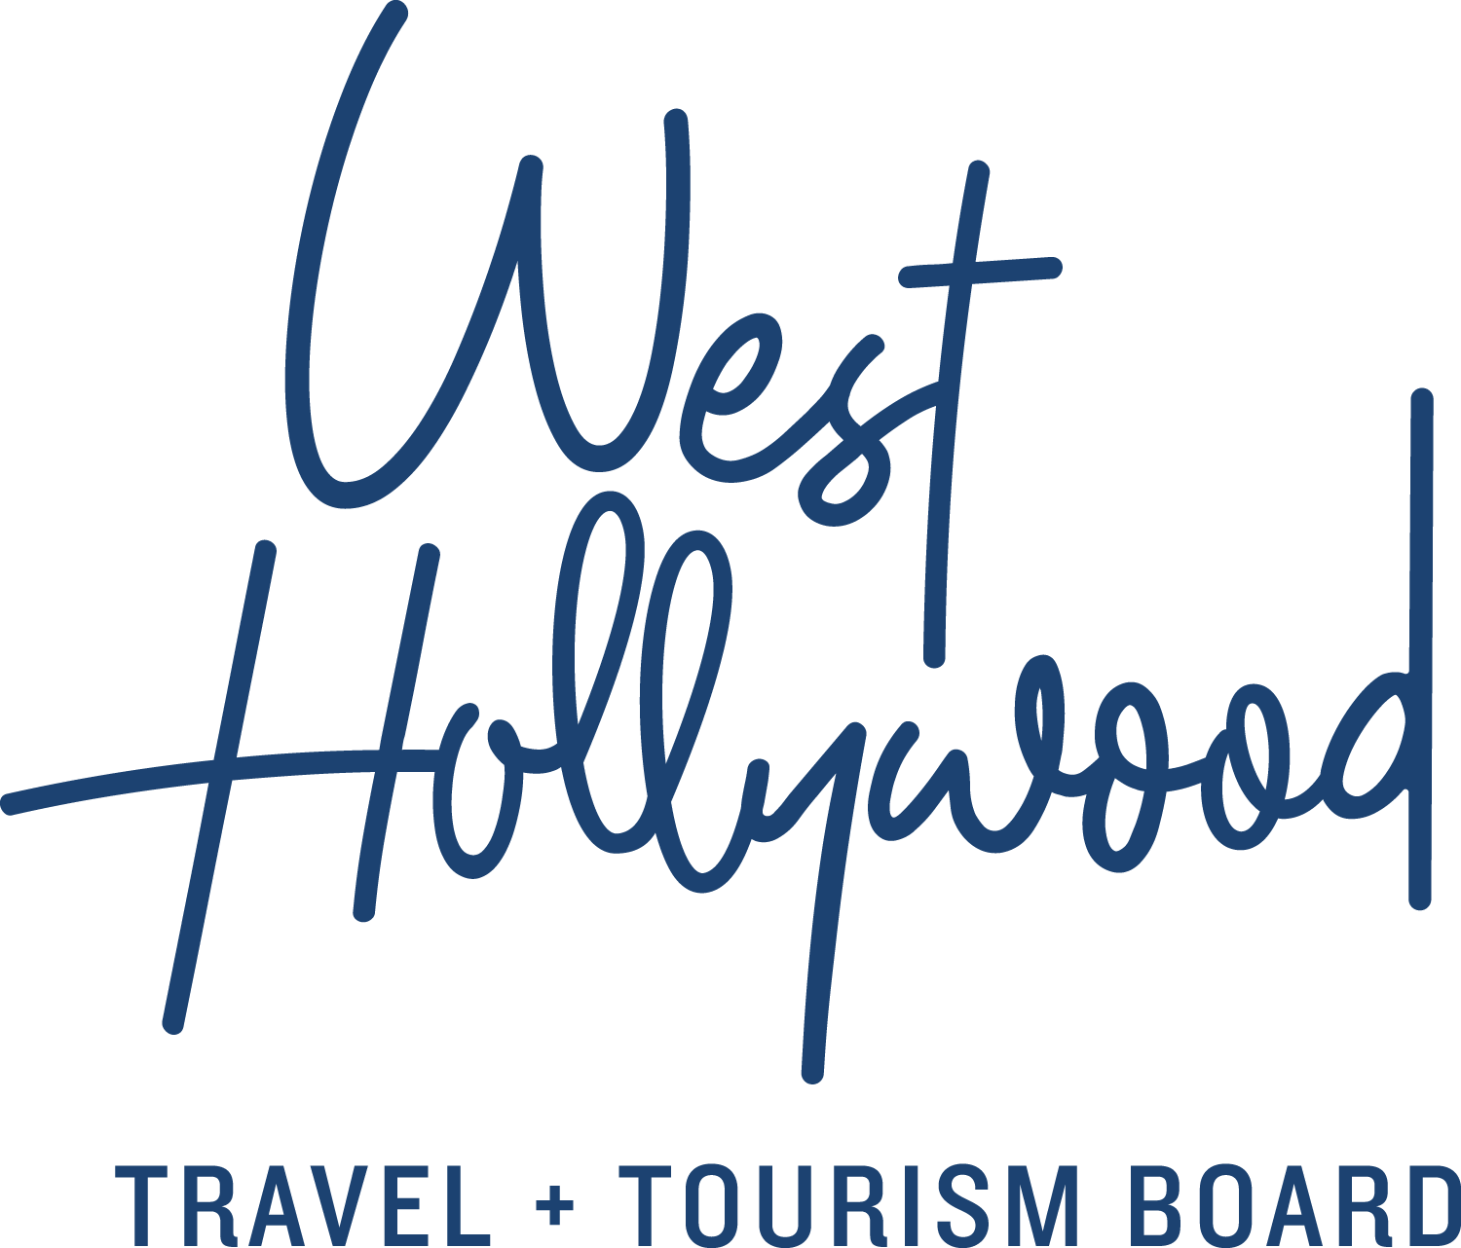

The Infamous and Colorful History of West Hollywood, California

Founded in 1984 as the 84th city in Los Angeles County, West Hollywood is a young, vibrant community with a colorful and entertaining past. Its history stretches back over 200 years, and the city proves to be a destination constantly reinventing itself again and again.
The Town of Sherman
In 1886, a real estate developer and entrepreneur named Moses Hazeltine Sherman bought a portion of Rancho La Brea from Hancock in order to construct segments of two electric railways, the Pacific and the Pasadena lines, which connected Los Angeles to the small, beachfront town of Santa Monica. At the intersection of the two railways, he established the headquarters of his Los Angeles Pacific Railway Co., the railway's power generators and a small residential area for railway workers—a settlement he named "Sherman."
With the emergence of the motion picture industry in the early 20th century, the town of Sherman became an attractive residential area for film stars working in nearby Hollywood, and soon the movie business entered the city itself. After founding the United Artists production company, Charlie Chaplin, Mary Pickford, and Douglas Fairbanks established the Pickford-Fairbanks Studios near Santa Monica Boulevard, which still exists today as The Lot. In 1925, the inhabitants of Sherman voted to change the name to West Hollywood in order to emphasize its relationship to its glamorous neighbor. However, the West Hollywood still technically remained an unincorporated region of Los Angeles County.

Emergence of the Sunset Strip
Due to its unincorporated status, West Hollywood both existed outside the jurisdiction of the Los Angeles Police Department and lacked a police department of its own. Loosely overseen by the Los Angeles County Sherriff’s Department, the region became a hotbed of liquor and nightlife. The dirt road at the northern border of West Hollywood, which served as the main commuter route between Beverly Hills and Hollywood, became known as Sunset Blvd., and nightclubs, hotels and restaurants sprung up along The Sunset Strip. Gambling, which was legal in Los Angeles County but not in the City of Los Angeles, brought money and the attention of mobsters like Bugsy Segal and Micky Cohen, regulars at Strip nightclubs like Ciro's (now The Comedy Store) and the Melody Room (now Viper Room). In the Golden Age of Hollywood, West Hollywood was the swankiest, most glamorous nightlife destination in the Los Angeles Metropolitan area.

West Hollywood added to its growing legend throughout the following decades. In the 60s and 70s, it became a major gathering place for the counterculture, with hippies, musicians and artists flooding the streets. Acts like Led Zeppelin, The Doors and Elton John won over crowds in emerging music venues such as The Troubadour, The Whisky a Go Go, and The Roxy. The Strip continued to be a cultural center for punk rock and new wave during the late 1970s, and evolved into the epicenter of the colorful glam metal and heavy metal scenes during the 1980s. Groups including Van Halen, Motley Crue and Guns N Roses redefined the standard for excess, with West Hollywood serving as their playground.

Becoming A City
Meanwhile, dispossessed and underserved minorities, most notably gay, lesbian and genderqueer-identifying people, flocked to West Hollywood to escape the persecution they faced at the hands of the LAPD and other city departments. At the same time, an influx of Russian Jewish émigrés fled the USSR and began to settle in the area. By the early 80s, rent prices in West Hollywood had begun to skyrocket, and the region's minority and elderly populations faced the prospect of being priced out of the neighborhood that they had helped create. In 1984, a coalition of gay men, Russian Jews and the elderly, spurred by the imminent expiration of L.A. County's rent control protections, successfully held a vote to officially incorporate the area as the City of West Hollywood, electing a city council with an openly gay majority and immediately passing a series of rent control measures to protect its longtime citizens. West Hollywood soon developed a reputation as a self-governed gay city and became a vanguard for progressive legislation, social change and LGBTQ culture.

At present, the city has grown to 36,000 residents and remains Los Angeles’ hottest destination for the entertainment industry with its boutique hotels, celebrity-owned restaurants, unparalleled nightlife and shopping and world-renowned events like the HBO Emmy Party, Sir Elton John’s Annual Oscar Party, LA PRIDE and the West Hollywood Halloween Carnaval. West Hollywood continues to set the standard for progressive, creative individuals on the cutting edge of trends and new ideas, working together as a community in one of the most exciting destinations in the country.

About West Hollywood Travel + Tourism Board
West Hollywood Travel + Tourism Board is the official marketing organization that invites visitors to West Hollywood, California, a walkable, 1.9 square mile/4.9 square kilometer city in the heart of Los Angeles. Located at the base of the Hollywood Hills and adjacent to Beverly Hills, West Hollywood is a creative and progressive city that embodies the quintessential L.A. lifestyle. West Hollywood is home to 17 hotels and comprised of three main districts: the world-famous Sunset Strip with unparalleled nightlife, eclectic and LGBTQ-friendly Santa Monica Boulevard, and the Design District known for its sought-after shopping and dining. West Hollywood enjoys a year-round moderate climate and thanks to its prime location and hip atmosphere, West Hollywood serves as home and playground to many celebrities. Follow us on Facebook & Twitter (@westhollywood) and Instagram (@visitweho). www.visitwesthollywood.com
##
Press Contact:
Anne Van Gorp, media@visitwesthollywood.com

