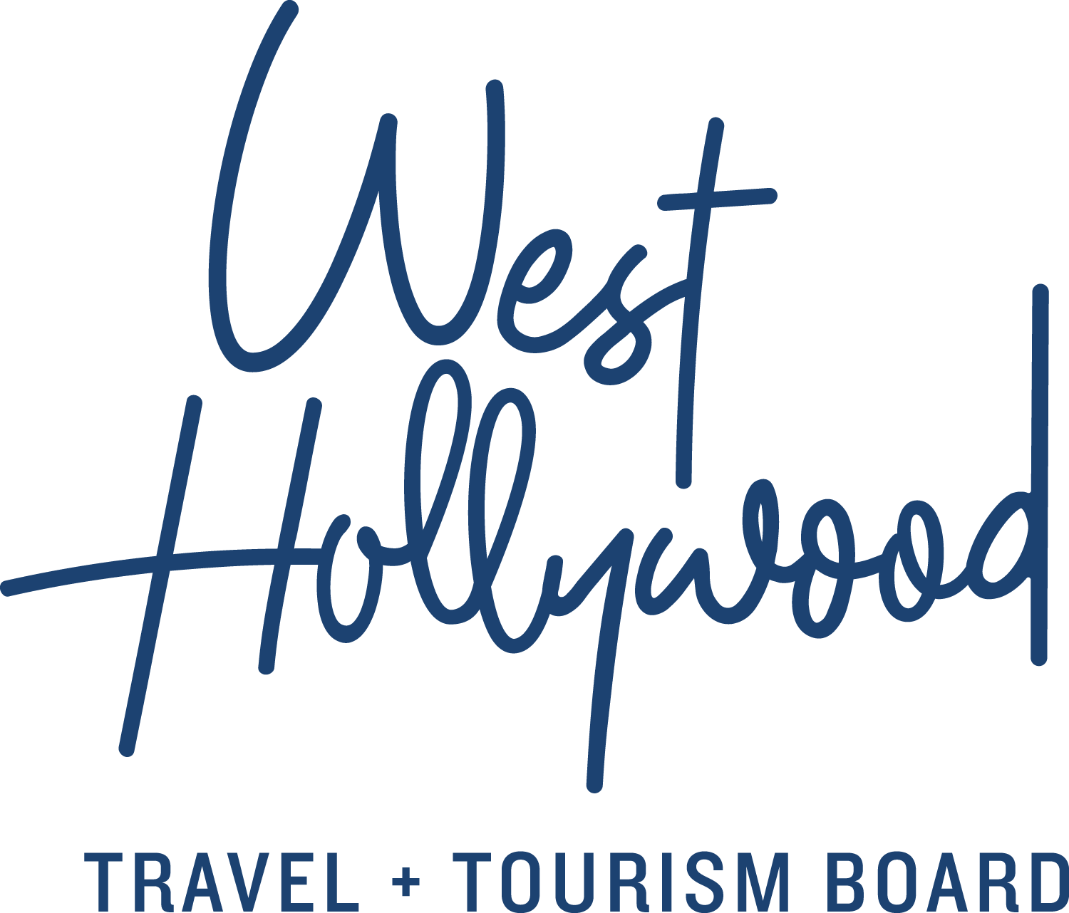
Fact Sheet – West Hollywood, California
Intro: West Hollywood Travel + Tourism Board is the official marketing organization
that invites visitors to West Hollywood, California, a walkable, 1.9 square mile/4.9 square kilometer city in the heart of Los Angeles. Located at the base of the Hollywood Hills and adjacent to Beverly Hills, West Hollywood is a creative and progressive city that embodies the quintessential L.A. lifestyle. West Hollywood is home to 17 hotels and is comprised of three main districts: the world-famous Sunset Strip with unparalleled nightlife, eclectic and LGBTQ-friendly Santa Monica Boulevard, and the Design District known for its sought-after shopping and dining. Follow us on Facebook & Twitter (@westhollywood) and Instagram (@visitweho). www.visitwesthollywood.com
What: West Hollywood is an incorporated city in California—distinct from Los Angeles and Hollywood—yet located in the heart of Los Angeles County. When most think of L.A., they imagine the cool urban spaces, bleeding-edge design, sounds and venues of nightlife, and the diverse lifestyle of West Hollywood, known by locals as WeHo. West Hollywood is located in the heart of Los Angeles, approximately 10 miles/16 kilometers away from Santa Monica and Downtown Los Angeles.
Origin: Originally named Sherman, but never fully integrated into the surrounding metropolis, West Hollywood became a haven for generations of creative thinkers, artists and rebels. Facing overdevelopment and impacted by the AIDS crisis, the city incorporated in 1984 to preserve its essence and protect civil rights.
Size: A jewel-box of a town, only 1.9 square miles/4.9 square kilometers.
Climate: Blue skies and sunshine year-round with light breezes and no humidity. The best time to visit is anytime, with unmatchable events such as Halloween Carnaval, LA Pride and Awards Season being the most popular.
Airports: Los Angeles International Airport (LAX), 12 miles/19 kilometers away, and Burbank Bob Hope Airport (BUR), 11 miles/18 kilometers away
Districts: The Sunset Strip: The Strip first gained notoriety during the 1920s as a playground for the early celebrities and mobsters. Today, legendary entertainment venues pay homage to its indulgent past. The Strip’s rebel spirit lives on today in supercharged restaurants, posh retail and urban hotels with some of the best city views, and exclusive clubs catering to jetsetters and pleasure seekers alike.
Santa Monica Boulevard: Considered “Main Street”, this is where WeHo locals eat, shop, and play. The LBGTQ+ restaurant and nightlife scene on Santa Monica Boulevard creates an energized nexus between La Cienega and Robertson Boulevards. Along this route, The PickUp trolley provides free bar hopping on weekend nights and Sunday Funday.
West Hollywood Design District: Feed your creativity, furnish your home and satisfy your culinary urges. At the crossroads of Melrose Avenue, Robertson and Beverly Boulevards, high-end showrooms, fashion houses and elevated dining destinations showcase vanguard options all within walking distance. Hand-chosen items by expert designers appear in West Hollywood’s best dressed hotel suites and rooftop pool decks; visitors may effortlessly replicate the vibe in their own spaces.
Lodging: West Hollywood currently has 19 establishments for lodging, ranging from vintage bungalows and motels, lovely all-suite hotels in quiet neighborhoods, comfy and assuring brand hotels and boutique chic hotels full of pampering and poolside pleasures. There is even a former movie star’s home available as grand apartment-type suites. Learn more at www.visitwesthollywood.com/hotels
Meetings: West Hollywood hotels have stunning and accommodating meeting space for events, corporate meetings, board retreats, and collaborative events where style is as important as substance.
We are: Rainbow-painted street crossings and year-round displays of pride flags are a welcome sign where the Lesbian, Gay, Transgender, Bisexual and Questioning community is celebrated; more than 40% of residents are LGBTQ. Many languages are spoken.
Assets: A sophisticated and extensive image collection and storytelling video library are available to media covering West Hollywood as a travel and lifestyle destination. Interviews with destination, design and local experts happily arranged. Hosted visits available for travel coverage fitting the brand.
Social: Facebook & Twitter (@westhollywood) and Instagram (@visitweho)
Web: www.visitwesthollywood.com
Contact: Anne Van Gorp / Media@visitwesthollywood.com

